STUDENT COPY – PRACTICAL SKILLS ASSESSMENT
Task Name: | Final Skills Assessment | Date: | 12/11/2024
Course Name: | CyberSecurity - Operations | Course Code: | INTE-2257
Student Name: | Vu Nguyen | Student Number: | S4010423

Assessment Information
INTE2557: Cybersecurity - Operations
Skills Assessment – Final

Introduction
You have been hired as a junior security analyst. As part of your training, you were tasked to determine any malicious activity associated with the Pushdo trojan.
You will have access to the internet to learn more about the events. You can use websites, such as Cisco Talos, to upload and verify threat existence.
The tasks below are designed to provide some guidance through the analysis process.
You will practice and be assessed on the following skills:
- Evaluate event alerts using Kibana, Squert, Sguil, Network Miner & Wireshark.
- Use Cisco Talos to upload and verify threat existence.
Content for this assessment was obtained from http://www.malware-traffic-analysis.net/ and is used with permission. We are grateful for the use of this material.

Required Resources
- Host computer with at least 8GB of RAM and 45GB of free disk space
- Latest version of Oracle VirtualBox
- Security Onion virtual machine requires 4GB of RAM using 25GB disk space
- Internet access
- If you choose to use the lab computer, you need to bring your own HDD drive with the downloaded Security Onion virtual machine
- Strong Knowledge on Lab 27.2.12, Lab 27.2.14, Lab 27.2.15 & Lab 27.2.16

Instructions

The skills assessment is a demonstration of your skills and knowledge in completing the labs work and cisco networking academy. The assessment will be performed and completed on-campus session, every task needs to be checked and signed by the assessor/teacher.

Part 1: Gather the Basic Information (20 Points)
In this part, you will demonstrate the alerts listed in Security Onion VM and gather basic information for the attack time frame.

Task 1: Verify the status of services (5 Points)
      - Log into Security Onion VM using the username analyst and password cyberops.
      - Open a terminal window. Enter the sudo so-status command to verify that all the services are ready.
      - When the nsm service is ready, log into Kibana with the username analyst and password cyberops.

Tasks | (5 Points)
sudo so-status (2.5 Points) | 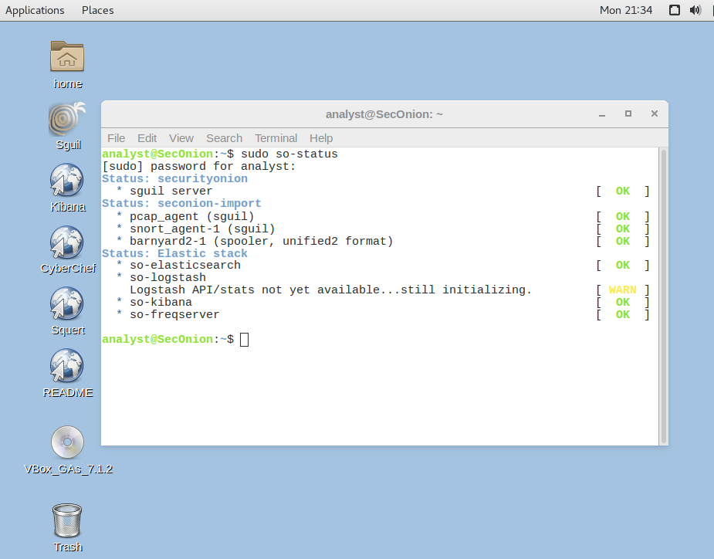
log into Kibana with the username analyst and password cybercops (2.5 Points) | 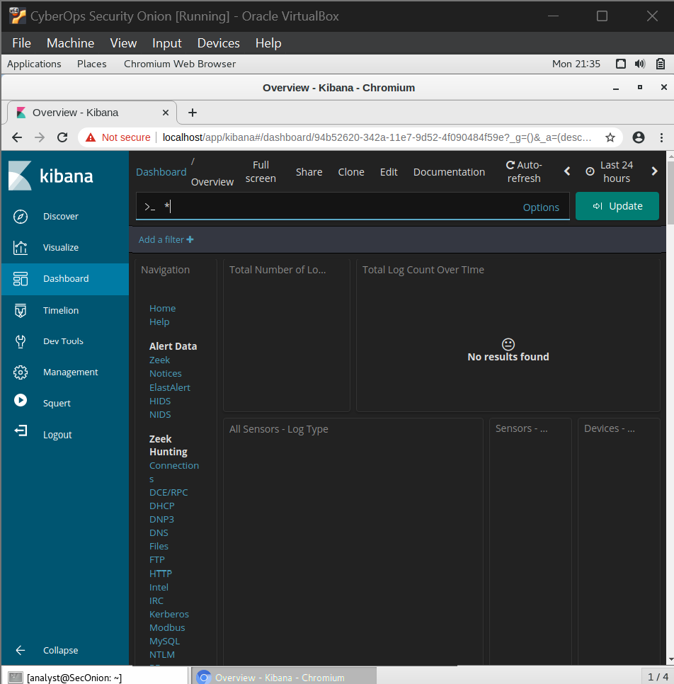

Note: Collect screen shot evidence in performing / completing the tasks.

Before proceeding, verify that’s Tasks 1 A, B & C are demonstrated with the assessor/teacher.
Instructor Sign-off Tasks 1: ______________________
Points: _________ of 5

Task 2: Gather basic information / logs using Kibana (15 Points)
      - Adjust the date and time range from 1 January 2017 to 31 December 2017 to Identify timeframe of the attack, including the date and approximate time. Show/Demonstrate what dates and time the events occurred. (2 Points)
How many total number logs that been recorded from 1 Jan 2017 to 31 Dec 2017 = 1937
      - Go to All logs section to determine the date of the attack. What is the date of the attack occurred? = 27th June 2017 (2 Points)

- Go back to the time range and adjust time range from 27 June 2017 13:00 to 27 June 2017 14:00 based on the date and time you have gathered. How many snort logs that it produced? = 27 (2 Points)

- Based on the graph. Show/Demonstrate the events that occurred. What is the start time and finish time that the attack occurred? =13:38-13:44 (4 Points)

- Go to the NIDSS – Alert Summary section and full-screen to inspect the alert logs Identify the internal IP address that the Pushdo trojan attack have been infected, Show/Demonstrate the events occurred. (5 Points)

What are the IP addresses associated with the attack?
Host computer infected IP: 192.168.1.96
External IP addresses: 62.210.140.158
Questions | Answers | Points
How many total number logs that been recorded from 1 Jan 2017 to 31 Dec 2017? (2 Points) | 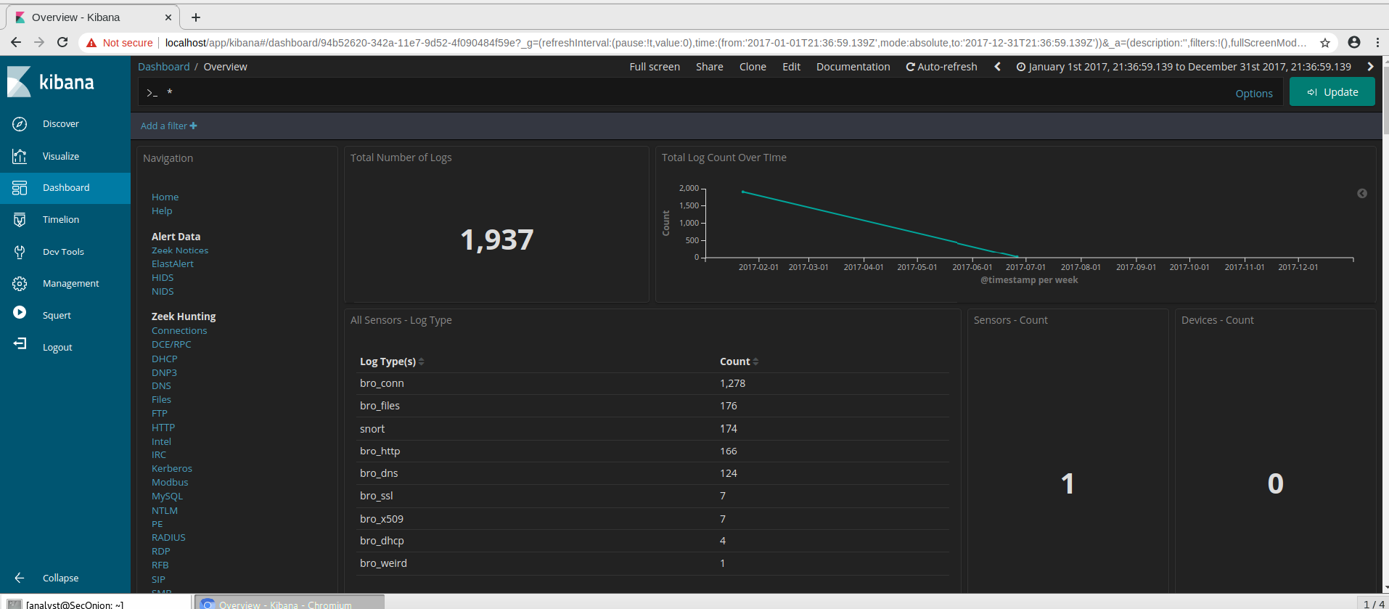
What is the date of the attack occurred? (2 Points) | 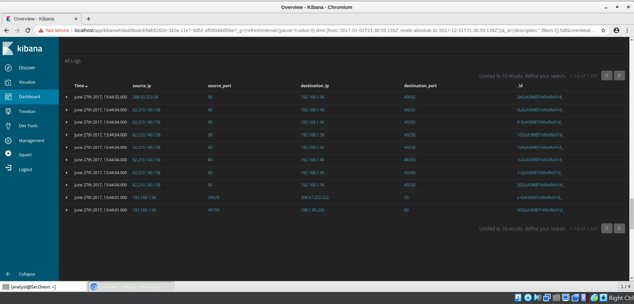
How many snort logs that it produced on? (2 Points) | 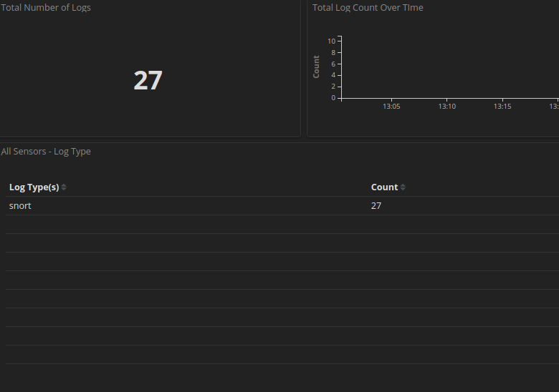
What is the start time and finish time that the attack occurred? (4 Points) | 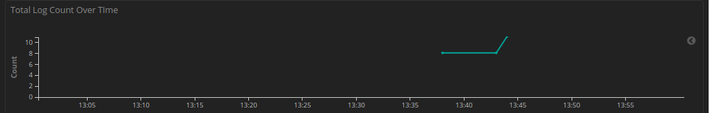
What are the IP addresses associated with the attack? (5 Points) | Host computer infected IP: 192.168.1.96  External IP addresses: 62.210.140.158  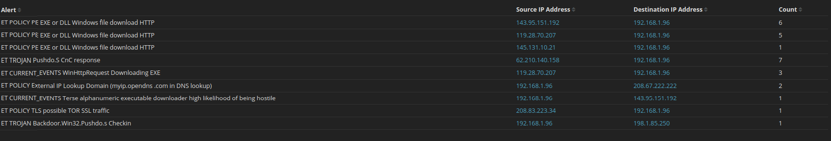

Note: Collect screen shot evidence in performing / completing the tasks.
Type your answers here.
Before proceeding, verify that’s Tasks 2 (A to F) are demonstrated with the assessor/teacher.
Instructor Sign-off Tasks 2: ______________________
Points: _________ of 15

Part 2: Learn about the Exploit using SQUERT & SGUIL (40 Points)
In this part, you will demonstrate more about the exploit using SQUERT and SGUIL. log into SQUERT with the username analyst and password cyberops.
TASK 2A: Open Squert tool in Kibana and adjust the date to 27 June 2017. Based on SQUERT what are the top Three (3) highest alert percentages that have been detected? (5 Points)

Time | % Alert | Signature | (5 Points)
13:43:53 | 41.379% | ET POLICY PE EXE or DLL Windows file download HTTP
13:44:04 | 24.138% | ET TROJAN Pushdo.S CnC response
13:38:34 | 17.241% | ET CURRENT_EVENTS WinHttpRequest Downloading EXE

Log into Sguil with the username analyst and password cyberops. What are Three (3) alerts need to be investigated? (5 Points)

Alert ID | IP Address | (5 Points)
5.415 | Source: 119.28.70.207  Destination: 192.168.1.96
5.420 | Source: 145.131.10.21  Destination: 192.168.1.96
5.422 | Source: 143.95.151.192  Destination 192.168.1.96

Task 2B: Examine the exploit using NETWORK MINER.
Open the top 3 alerts associated with the exploit, what are the three (3) files downloaded? Show the lists of the malicious domains observed, and the files downloaded by completing the table below. (15 Points)

Alert ID | File Downloaded | Website Downloaded | (15 Points)
5.415 | Gerv.gun.octet-stream | Matied.com | 5 Points
5.420 | Trow.exe | Lounge-haarstudio.nl | 5 Points
5.422 | Wp.exe | Vantagepointtechnologies.com | 5 Points

Note: Collect screen shot evidence in performing / completing the tasks.

Task 2C: Finding the HASH using NETWORK MINER.

Use Network Miner to demonstrate, in determining and recording the SHA256 hash for the downloaded files that probably infected the computer? (15 Points)

File Name | Date & Time | SHA256 Hash | (15 Points)
Gerv.gun.octet-stream | 06/27/2017  1:38 PM |  | 5 Points
Trow.exe | 6/25/2017 1:43 PM |  | 5 Points
Wp.exe | 6/27/2017  1:43 PM |  | 5 Points

Note: Collect screen shot evidence in performing / completing the tasks.

Before proceeding, verify that’s Tasks 2 (A-C) are demonstrated with the assessor/teacher.
Instructor Sign-off Tasks 2: ______________________
Points: _________ of 40

Part 3: Research the Malware using Cisco Talos Website (10 Points)
Navigate to input the SHA256 hash that you have determine if these were detected as malicious files. Demonstrate your findings, such as file type and size, other names, and target machine. (10 Points)
https://talosintelligence.com/

Tasks | (10 Points)
Gerv.Gun File Reputation from Cisco Talos Site
Trow.Exe File Reputation from Cisco Talos Site
WP.Exe File Reputation from Cisco Talos Site

Note: Collect screen shot evidence in performing / completing the tasks.

Before proceeding, verify that’s Tasks 3 are demonstrated with the assessor/teacher.
Instructor Sign-off Tasks 3: ______________________
Points: _________ of 10

Part 4: Report Your Findings using WireShark (10 Points)
Summarizes your findings based on the information you have gathered from the previous parts, be brief and concise in your report. (10 Points)
Infected Host Information Table
Information | Answers | (10 Points)
Host IP address: |  | 2 Points
Host MAC address: |  | 2 Points
Host Port: |  | 2 Points
Web Browser: |  | 2 Points
Website: |  | 2 Points

Note: Collect screen shot evidence in performing / completing the tasks.
Type your answers here.
Before proceeding, verify that’s Tasks 4 are demonstrated with the assessor/teacher.
Instructor Sign-off Tasks 4: ______________________
Points: _________ of 10

Part 5: Collection of Evidence (20 Points)
Complete the Table of Evidence in attaching the screenshots based on the tasks that you completed. (10 Points)

Description | Screenshots
Part 1  Evidence 1: sudo so -status of the cybersecurity tools will be used using terminal (0.5 Point) | 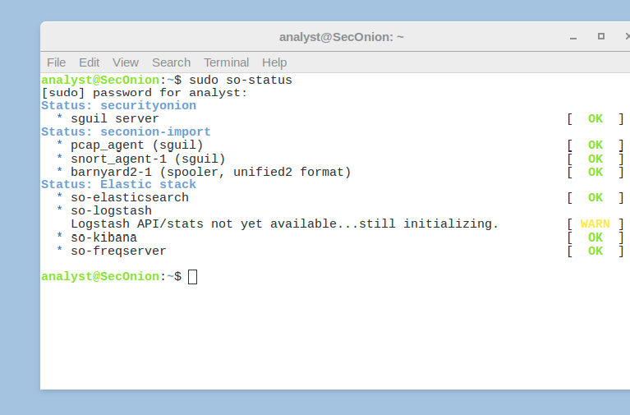
Evidence 2: Login to Kibana (0.5 Point) | 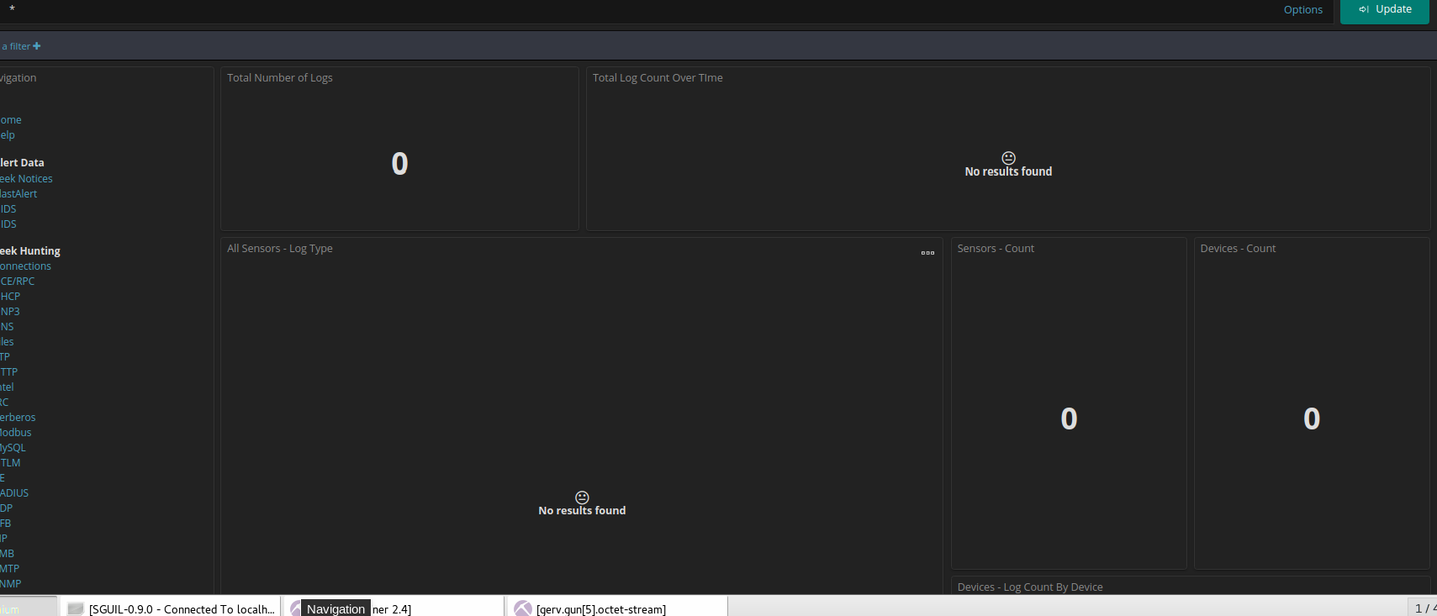
Evidence 3: Adjust time and date range in Kibana (0.5 Point) | 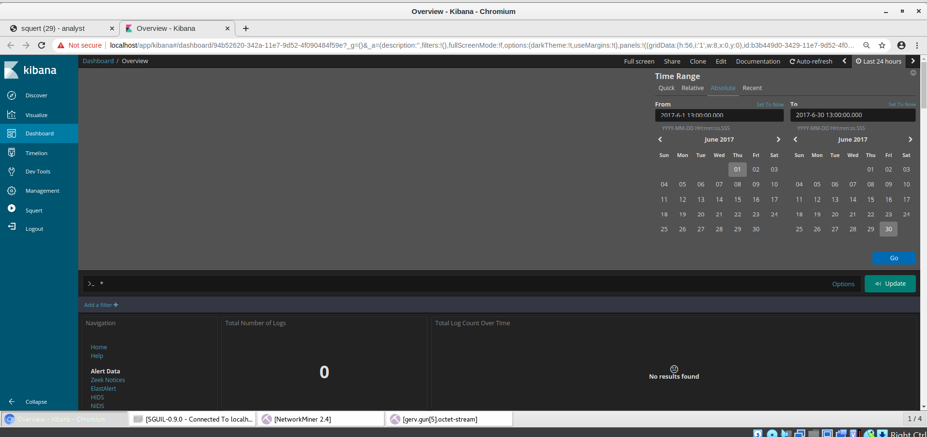
Evidence 4: Total log alert in Kibana from 1 Jan to 31 Dec 2017 in Kibana (0.5 Point) | 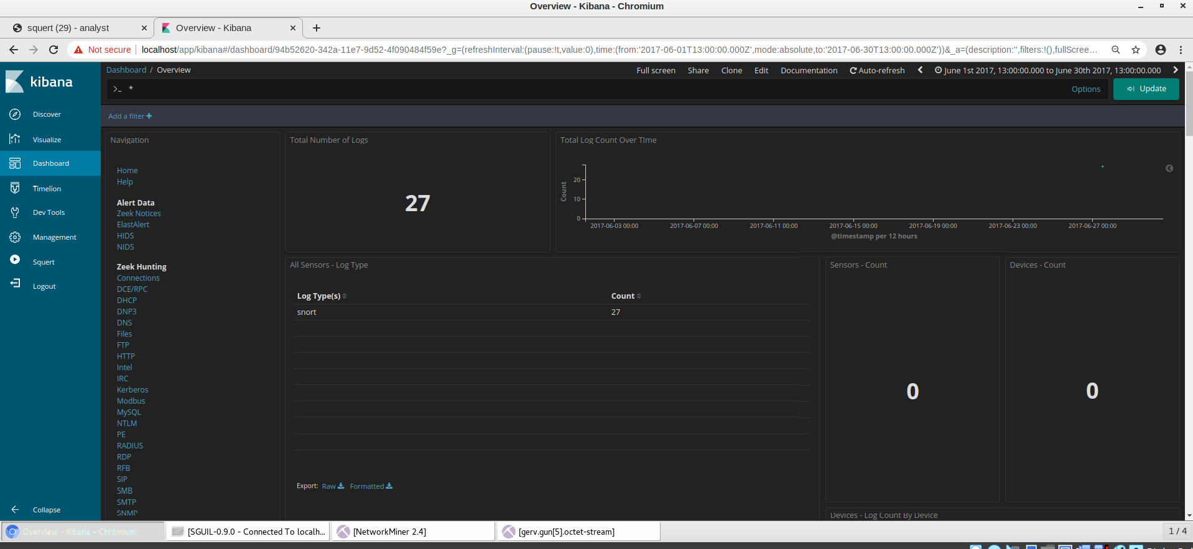
Evidence 5: Determining date and time is Kibana Logs (1 Point) | 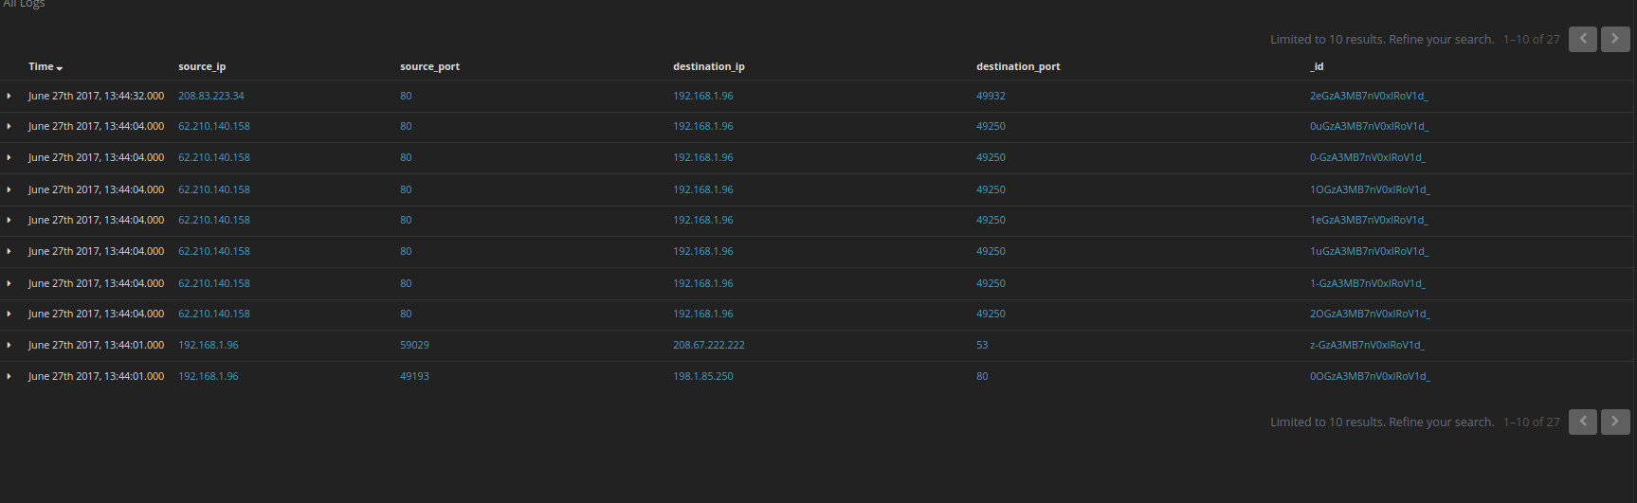
Evidence 6: Adjusting the time range to 27 June 2017 with total alert logs on the day in Kibana. ( 2 Points) | 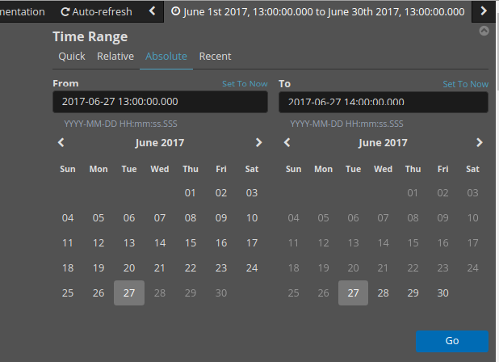
Evidence 7: Determining the start time of the attack in Kibana (1 Point) | 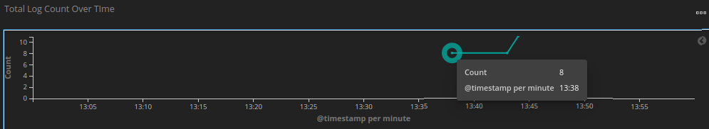
Evidence 8: Determining the finish time of the attack in Kibana (1 Point) | 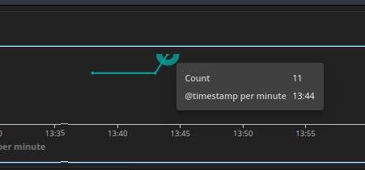
Evidence 9: showing the list of alerts related to the Pushdo Trojan Attack in Kibana (2Points)
Part 2  Evidence 10: Using SQUERT present evidence of the top 3 alert percentage detected (2 Points) | 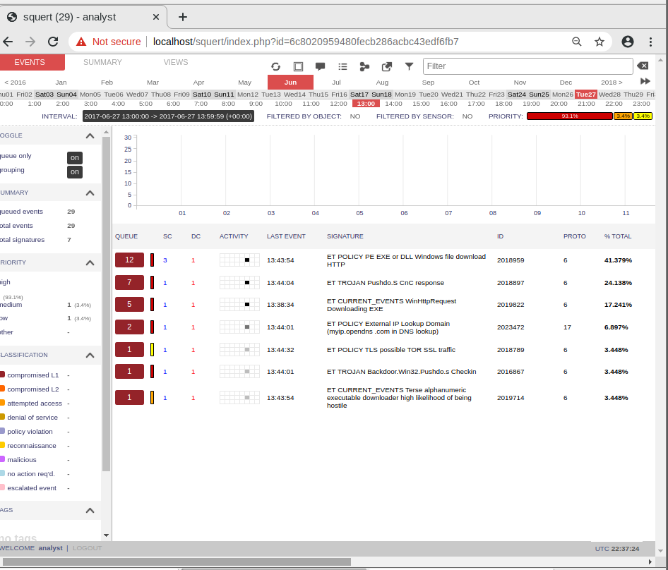
Evidence 11:  Using SGUIL present the three (3) Alerts of the source IP address where the malware is downloaded.  (2 Points) | 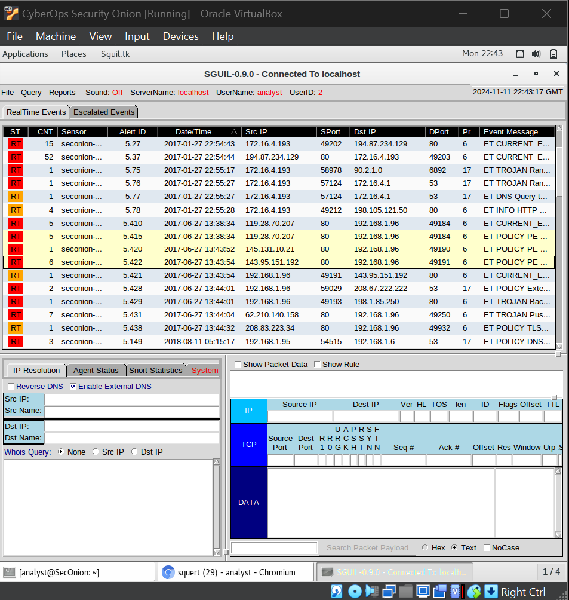
Evidence 12:  Using Network Miner present Alert 5410 (0.5 Point)  and SHA256 HASH (0.5 Point) | 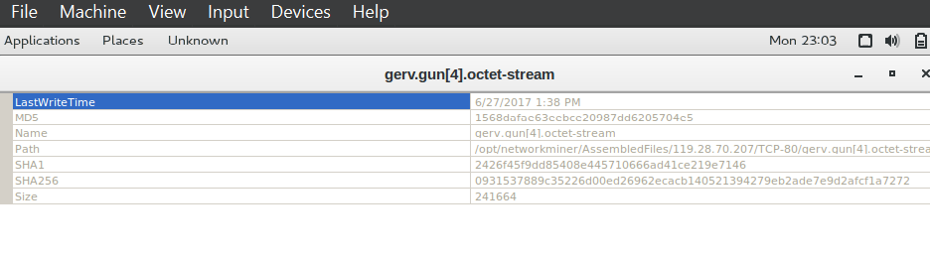  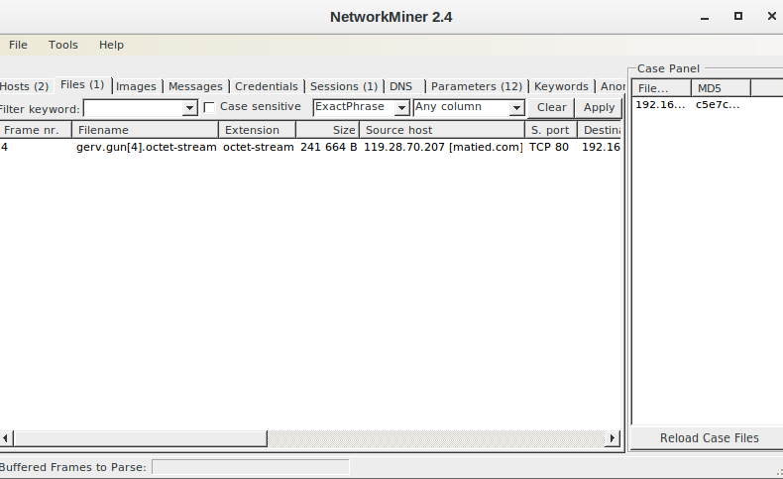
Evidence 13: Using Network Miner present Alert 5420 (0.5 Point)  and SHA256 HASH (0.5 Point) | 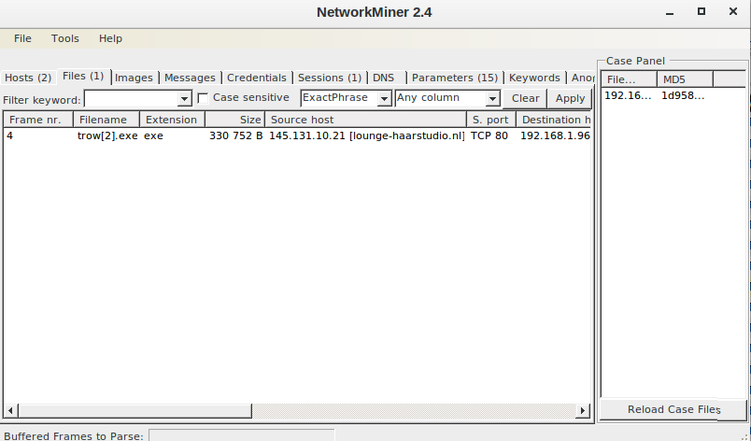  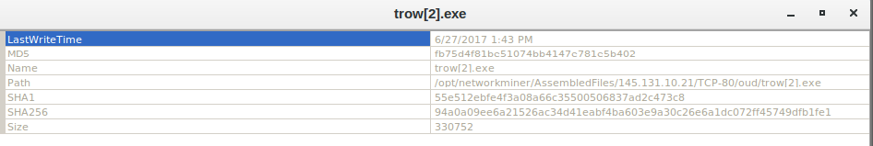
Evidence 14: Using Network Miner present Alert 5421 (0.5 Point)  and SHA256 HASH (0.5 Point) | 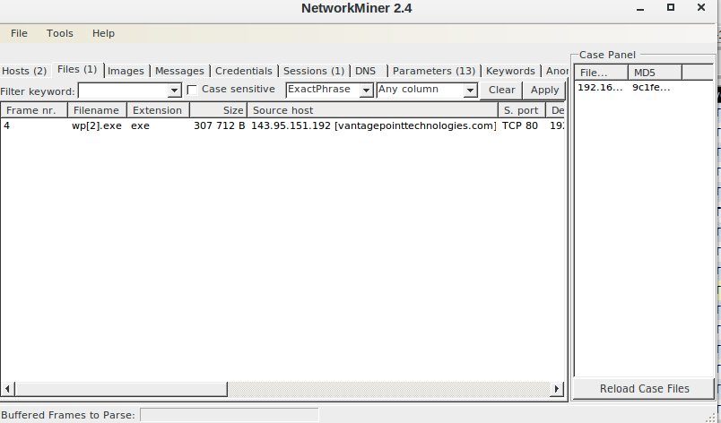  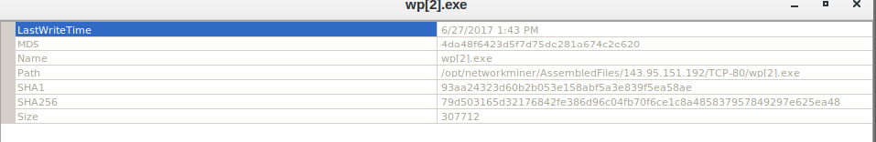
Evidence 15: Alert 1: Show gerv.gun web information from Cisco Talos (0.5 Point)
Evidence 16: Alert 2: Show trow.exe web information from Cisco Talos (0.5 Point)
Evidence 17: Alert 3: Show wp.exe web information from Cisco Talos (0.5 Point)
Evidence 18: Using Wireshark demonstrate your findings on the infected host information (1 Point)

Final Score
Part 1: / 20
Part 2: / 40
Part 3: / 10
Part 4: / 10
Part 5: / 20

Points: _________ of 100
Instructor Sign-off: ______________________

